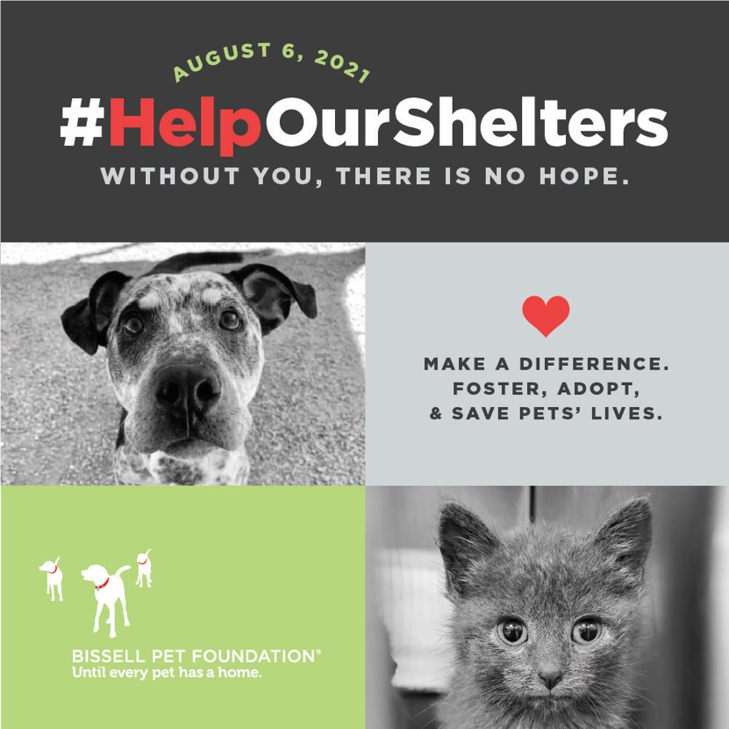

LOGO
YOUR SHELTER NAME HERE Asking the Public for Help
National organizations, shelters across the country
come together with urgent plea for adopters and fosters

CITY, STATE (DATE) – Shelters across the country are in crisis with overcrowding and other major obstacles, prompting a national call-to-action for help. Due to seasonal high-intake, short-staffing, decrease in shelter veterinarians, and slowing adoptions, shelters are struggling to care for all the animals in their adoption agencies. National animal welfare organizations are coming together in support of the country’s municipal shelters including YOUR SHELTER NAME HERE to get the word out that adoption and fostering are especially critical at this moment.

YOUR SHELTER NAME HERE is currently experiencing XXX percent capacity, with XXX animals currently in care. INSERT DETAILS ABOUT 2020 TO 2021 COMPARISON, CURRENT CAPACITY ISSUES, EUTHANASIA RATES AND OTHER DATA.

QUOTE FROM YOUR SHELTER HERE

Numerous factors are making this a particularly tough time for animal shelters. These include:

- Pet owners being forced to give up their pets due to housing loss, financial struggle, and other impacts of COVID.
  - With the eviction moratorium ending, it’s estimated that 11 million pets will be impacted with the loss of their family homes, according to the Humane Society of the United States. It is estimated 72 percent of all renters have at least one pet.
- Like other industries, animal adoption agencies are facing widespread staffing challenges, and many organizations lack the number of needed staff to accommodate all their animals.
  - There is a national shortage of 7,000 shelter veterinarians, according to American Pets Alive!
- Adoption and foster placements have slowed nationally, as vacation travel resumes.
  - INSERT ANY STAT ABOUT ADOPTION AND FOSTER HERE

To engage with potential adopters and fosters, BISSELL Pet Foundation along with partners Maddie’s Shelter Medicine Program at the University of Florida, Human Animal Support Services (HASS), The Association for Animal Welfare Advancement, National Animal Care & Control Association, Code 3, American Pets Alive!, and Best Friends Animal Society are working together along with municipal shelters and rescues to create a nationwide awareness campaign about the dire need for help.

On Friday, August 6, 2021, shelters and partners will take-part in a national awareness campaign on social media. Using the hashtag #HelpOurShelters, shelters will share their stories and encourage their community members to provide help by becoming foster families and/or adopting a cat or dog into their home. The awareness campaign is to demonstrate the scope and size of the countrywide need for support, and the state of crisis these shelters are struggling with every day.

“There are so many issues that are impacting animal welfare organizations across the country, and it’s finally gotten to a pressure point that every shelter is in dire need of support,” said Cathy Bissell, Founder of BISSELL Pet Foundation. “We understand the shelters are struggling and hope to provide some relief through this collaborative call for help with other national organizations.

Without the public’s help, healthy, adoptable pets will face euthanasia in animal shelters this summer. The community’s actions can make all the difference, including the following tips:

- Adopt. Adopting helps open space at the shelter and provides a safe, loving environment for the animal.
- Foster. Fostering a pet will free up a kennel space for another pet who urgently needs one. In many places, moms with puppies/kittens, orphaned babies, pets recovering from injury or illness, and long-stay pets urgently need foster homes.
- Help get lost pets back home. When finding a friendly, healthy lost pet, file a found report, get it scanned for a microchip at a local vet, and hold the pet for at least 48 hours and try to get it home without coming to the shelter. When Good Samaritans help get lost pets home, it keeps the shelter population manageable. More information about helping pets without bringing them to a local shelter is available on www.humananimalsupportservices.org.

About YOUR ORGANIZATION

About BISSELL Pet Foundation:
BISSELL Pet Foundation is a charitable 501©(3) nonprofit organization with a mission to help reduce the number of animals in shelters through pet adoption, spay/neuter programs, microchipping and emergency support. Founded in 2011 by Cathy Bissell, BPF is an extension of her long-standing love for animals and commitment to their welfare. BPF has since partnered with more than 5,300 shelters and rescues across the U.S. and Canada to help pets find loving homes. The foundation is supported by generous donors and BISSELL Homecare, Inc where every purchase saves pets.

For more information on BISSELL Pet Foundation and the efforts to curb the national shelter crisis, visit www.BISSELLPetFoundation.org and follow on social media including Facebook www.facebook.com/BISSELLPets and on Instagram at @BISSELLPets.

###

Media Contact:
YOUR MEDIA CONTACT INFO
Tori Allen | BISSELL Pet Foundation | PR & Communications Specialist | tori.allen@bissell.com, 732.673.4222

