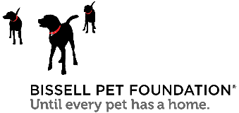

Shelter Crisis
Talking Points

STAFFING SHORTAGES
- 88% of shelters noted that they were short on staffing
- A national shortage of veterinarians is impacting access to vet care in shelters
- Due to understaffing, most organizations say staff are more stressed than usual
  - Many are unable to carry out regular operations such as:
    - Hosting major adoption events
    - Supplying enough veterinary support
    - Maintaining regular hours with public access
    - Providing as much sufficient adoption/foster support and animal care as they would like

HOUSING INSTABILITY & COST OF CARE
- Pet ownership spiked to 70% in 2020 during the pandemic
- 72% of renters own at least one pet
- Problems finding and keeping rental housing lead to the surrender of half a million pets to shelters each year.
- Americans are facing are facing record housing unaffordability and near-record housing shortages, which places pets at risk.
- Shelters are reporting a record number of surrenders due to housing in 2023 over 2022.
- Pet services, including veterinary costs, have increased more than 9% in the last year.
- 42% of pet owners said a vet bill of $999 or less would cause them to go into debt, and 44% said they used their credit card to pay for a vet bill.

INCREASE IN ANIMAL INTAKES, LENGTH OF STAY & EUTHANASIA
- Animal intakes at both public and private shelters across the country are expected to reach a 3-year high in 2023, and adoptions or returns to owners are not keeping pace
- Pets are waiting in shelters longer to be adopted than any time in the past four years, which has contributed to the capacity crisis
- There has been a nearly 25% increase in euthanasia in 2023 over 2022 in organizations surveyed
- Stray dog intakes continue to increase year over year since 2021
- The number of pets relinquished by owners has increased in private shelters.

